|  |  |
| --- | --- |
|  | **Stratego a Go Go!!** |
|  | CSSE376  Kimberly Boucher  Nicholas Miller  Daniel Wells |

|  |
| --- |
| **[Problem Statement]** |
|  |



High Level Problem Summary

# Elevator Statement

Board game players are not able to play the popular board game Stratego without the physical board and easily misplaced game pieces, so we have decided to make a Stratego computer application to allow people to easily play Stratego whenever and wherever they wish.

# ****Summary of Primary Success Criteria****

* Our application has a GUI on which users can play the game of Stratego, indicating their moves and viewing the state of the board at any time.
* Two players can play a game of Stratego against each other on our application over a network.
* One player can play a game of Stratego against a computer AI in our application.
* Support for English and Spanish languages will be included.

# ****Scope****

**The focus of the project is the playing of Stratego. No other games will be covered. The application will not provide hints, strategies, or tutorials related to gameplay; only the rules will be included. Visuals will be simplistic, with minimal to no sound effects.**

Detailed Problem Statement

# Function

The application will be a Windows executable application. It will have a GUI. The program will offer the options of playing a game, reviewing the rules of the game, and changing the program’s settings.

## Key Business Features

In-game, the application will offer multiple helpful features, including the ability to see available moves, see available opponent moves, save and load games, and a timer indicating the duration of the current game and turn.

## Key Enabling Features

The program will be written in C#. It will feature a peer-to-peer multiplayer network. The computer opponent will be operated by a machine learning system. No external informationis stored.

## Key Concurrency Issues

There are no concurrency issues in our project due to the turn-based nature of this game.

# Form

## Key Attributes

* **Performance and capacity**: Low intensity operations, such as navigating menus, changing minor settings, and entering a move should occur almost instantaneously. Higher intensity operations, such as saving or loading a game, changing major settings, and AI turn execution, should occur in a reasonable period of time, such as less than 10 seconds. Only one game would be active at a time. The number of games saved would be limited only by the size of the operating computer’s storage space.
* **Reliability and availability**: There should be no errors in the game logic, saving games, and loading games. AI opponents may not always make a good play, but they should at least be valid plays.
* **Usability**: The GUI provided should be sufficient for one with understanding of the rules of Stratego to be able to easily execute any available action they so desire.
* **Security**: No sensitive data is collected, so the only security required relates to maintaining the game state. Players should not be able to interfere with their opponent’s turns, nor should they be able to perform any invalid moves.
* **Modifiability, maintainability,& customizability**: No sort features related to modification or customization of the program will be provided. The program will be provided as is, and any changes will require explicit altercation to the source code.
* **Testability**: The business logic of the game and the GUI will be tested completely separately. The GUI will mostly consist of buttons, which will limit the amount of input sanitation necessary. Finally, the features of the GUI itself will be statically placed, allowing simple testing.

## Hardware & Software Constraints

The application will be designed as a Windows desktop application. The language used will be C#.

## Key Interfaces

A data format for the saved games will be specified. A peer-to-peer protocol will be used to connect two users for multiplayer games.

# Economy

The business model will be based around advertising. The service itself will be free to use, but non-intrusive advertisements may be included if profit is desired. However, because of copyright issues, it is unlikely that any profit will be sought.

# Time

The game of Stratego has existed since 1947. However, the game largely exists in a purely physical format. This movement to a digital version of the game allows more people to be exposed to and play the game. The digital format also allows easy modification, potentially allowing for many variants of the game in the future.

# Key Stakeholders

|  |  |
| --- | --- |
| Name | Title |
| Sriram Mohan | Project Advisor |
| Kimberly Boucher | Team Member |
| Nicholas Miller | Team Member |
| Daniel Wells | Team Member |
| Stratego Players | End User |

Rules of Stratego

# Objective:

* To capture your opponent’s flag.

# Contents:

* One game board with squares arranged in 10 rows and 10 columns.
* Two armies, one red and one blue, of 40 pieces each, containing:   
   1 Marshall (1)  
   1 General (2)  
   2 Colonels (3)  
   3 Majors (4)  
   4 Captains (5)  
   4 Lieutenants (6)  
   4 Sergeants (7)  
   5 Miners (8)  
   8 Scouts (9)  
   1 Spy (S)  
   6 Bombs (B)  
   1 Flag (F)

# To Start the Game:

* One player takes the red pieces and the other takes the blue pieces.
* Both players place their pieces facing themselves so their opponent cannot see what rank they are.
* They may be arranged in any order in the four rows closest to the player.
* Once all 40 pieces are placed, the game begins. Red has the first turn.

# On Your Turn:

* A player may move one piece per turn.
* Flags and bombs cannot be moved.
* The piece may be moved forward, backward, left, or right (but not diagonally).
* All pieces except the scout (see below) can only move one square per turn.
* Two pieces may not occupy the same square.
* There are two lakes in the center of the board which may not be moved into. Pieces must move around the lakes.
* A friendly piece may move into an enemy square. This is called “striking.”
* When one piece strikes another, both players announce the rank of their pieces. The piece with the lower rank is removed. If the attacking piece wins it occupies the square of the defending piece.
* When pieces of equal rank are struck, both pieces are removed.
* The spy has the lowest rank, but if the spy strikes the marshal it wins the exchange. However, the spy loses **any** encounter where it is defending.
* The scout may move as many squares as he wishes in a straight line, but may not move through friendly or enemy pieces He may not strike on the same turn that he moves.
* When any piece (except a miner) strikes a bomb, that piece is lost and removed from the board. The bomb remains in its original position at all times. If a miner strikes a bomb the bomb is removed and the miner moves into the unoccupied square.
* If a piece strikes a flag, the flag is removed and the game ends. The player who struck the flag is the winner.

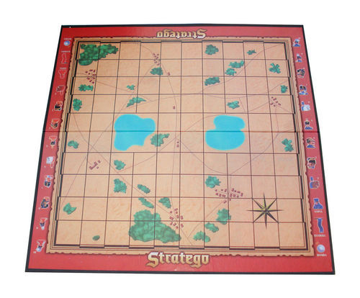

<http://cf.geekdo-images.com/images/pic327485_md.jpg>